Work 3. Optimal control design for LTI plant (LQR)

Problem statement
Linear plant and quadratic cost of variant 5:
$\overset{˙}{x}=Ax+bu,u=−Kx$
$A=\left[\begin{matrix}0 & 1 \\ −2 & 5\end{matrix}\right], b=\left[\begin{matrix}0 \\ 3\end{matrix}\right], Q=\left[\begin{matrix}1 & 0 \\ 0 & 2\end{matrix}\right], r=5$
$J=\int_{0}^{∞}{(x^{T}Qx+ru^{2})dt}$

Optimal controller (Riccati), simulation of x1, x2, u, J
Solving the algebraic Riccati equation gives P and the gain K=r^-1 b'P. The closed-loop matrix A-bK is Hurwitz. The variables x1, x2, u and the accumulated cost J are plotted separately for x(0)=[1,0]'.
K = ['0.1361', '3.4746']
closed-loop eigenvalue real parts = ['-0.4879', '-4.9358']
steady-state cost J = x0' P x0 = 12.8122
accumulated cost over the simulation (T=8) = 12.8054
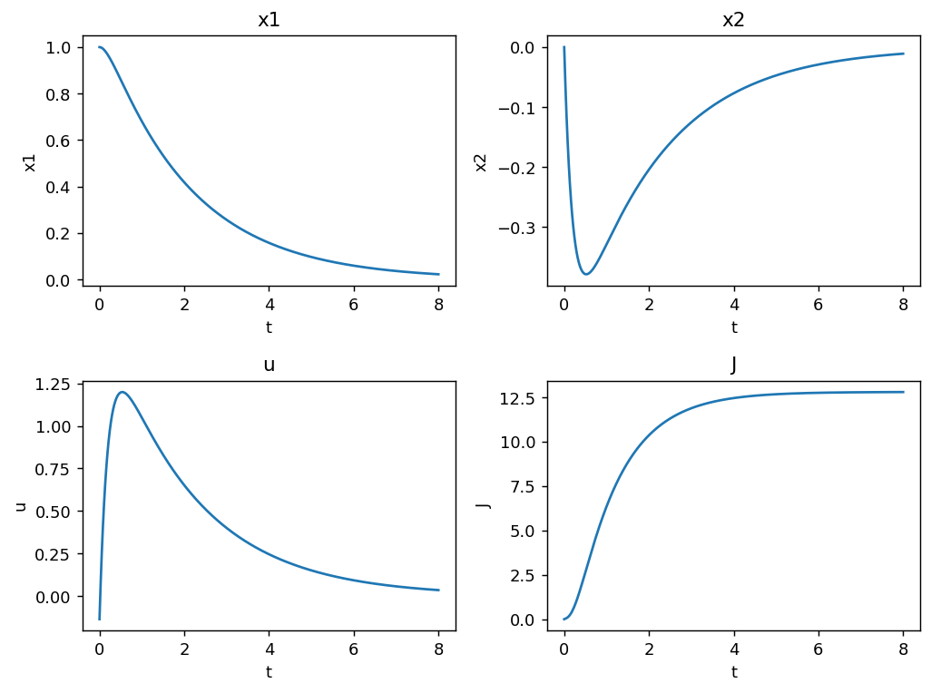

Slightly changed K (stability preserved)
Increasing the gain by 5% keeps stability but raises the steady-state cost, confirming K is optimal. Experiment 2 is repeated with the same simulation time and x1, x2, u, J are compared with the optimal case.
perturbed closed-loop eig real parts = ['-0.4413', '-5.5036']
optimal J = 12.8054, perturbed J = 12.8237
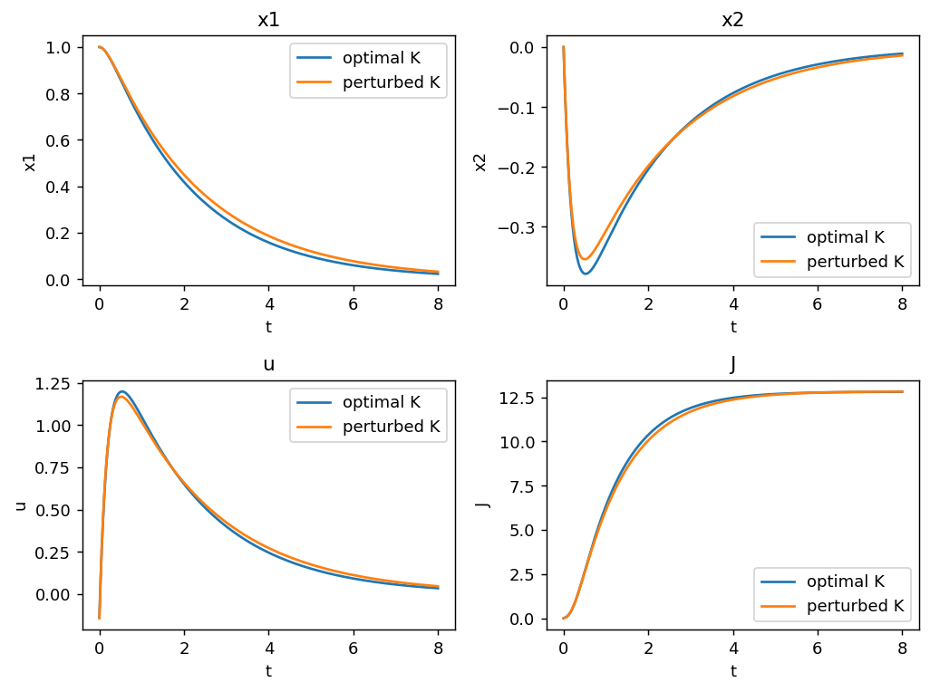

Three r and three Q=kQ*
For three values of r and three matrices Q=kQ* the variables x1, x2, u and J are plotted. Larger r penalizes control effort (slower, cheaper control); larger Q penalizes the state (faster response).
